output of program cpu scheduling
Names :
1- وعد عبدالرحمن المطيري4452933
2- وصال فايز الجهني 4451758
3- جنى فواز المطيري4453578
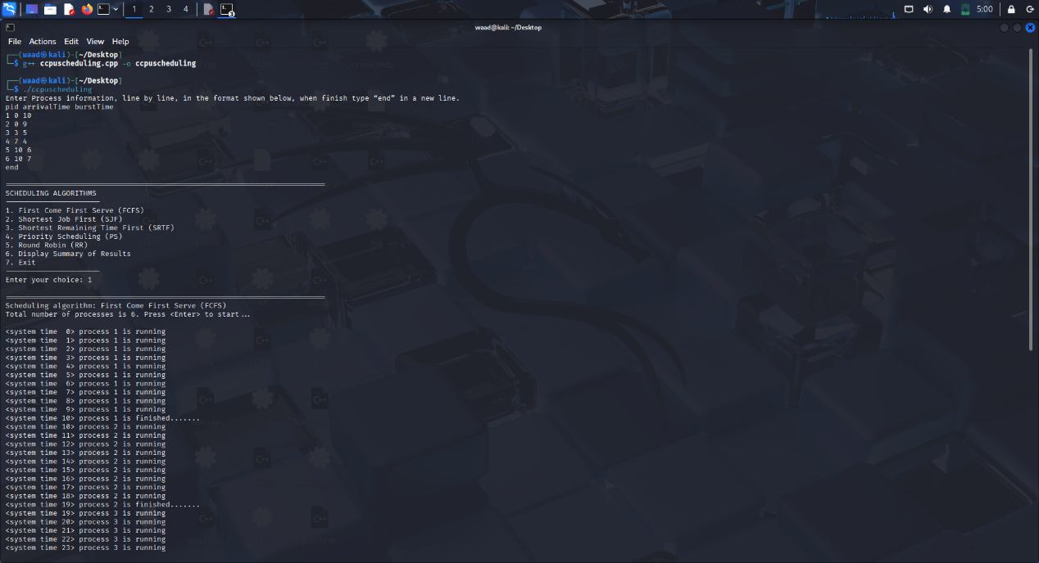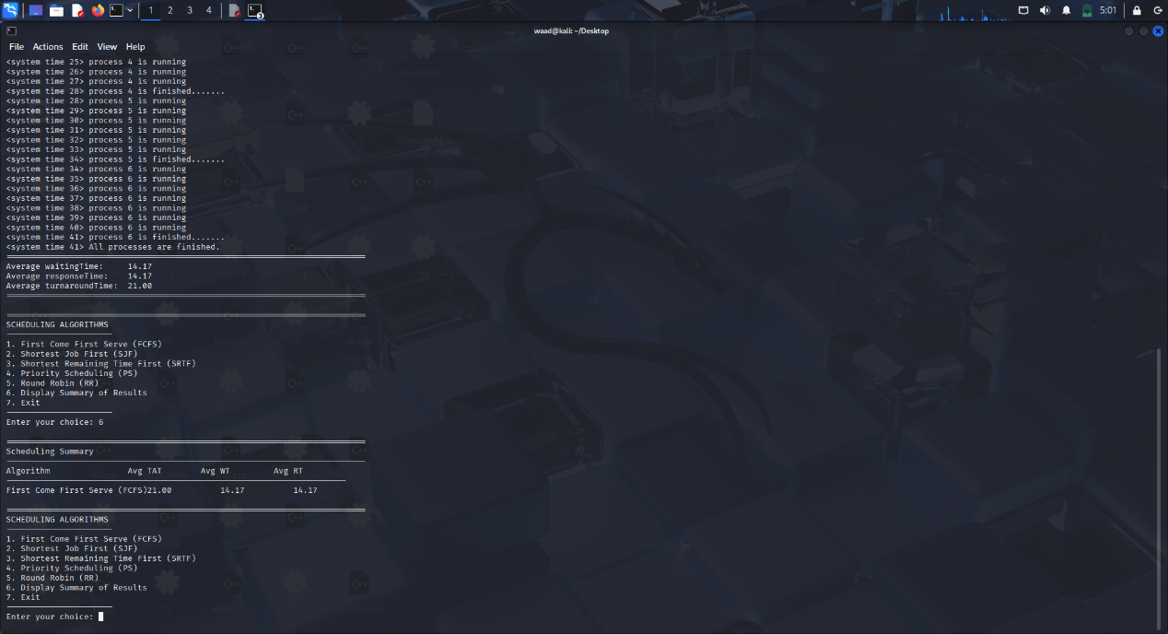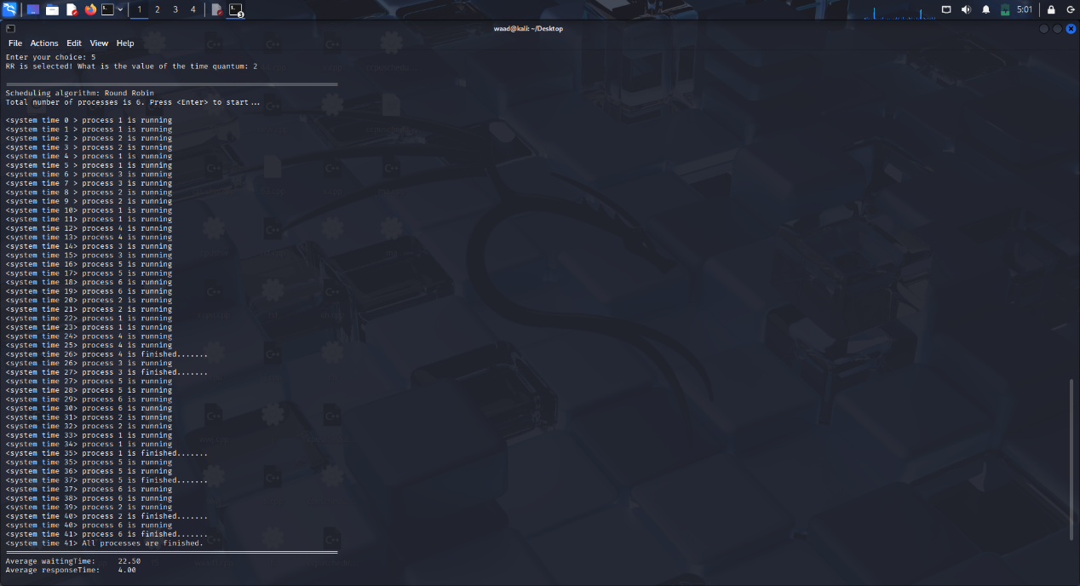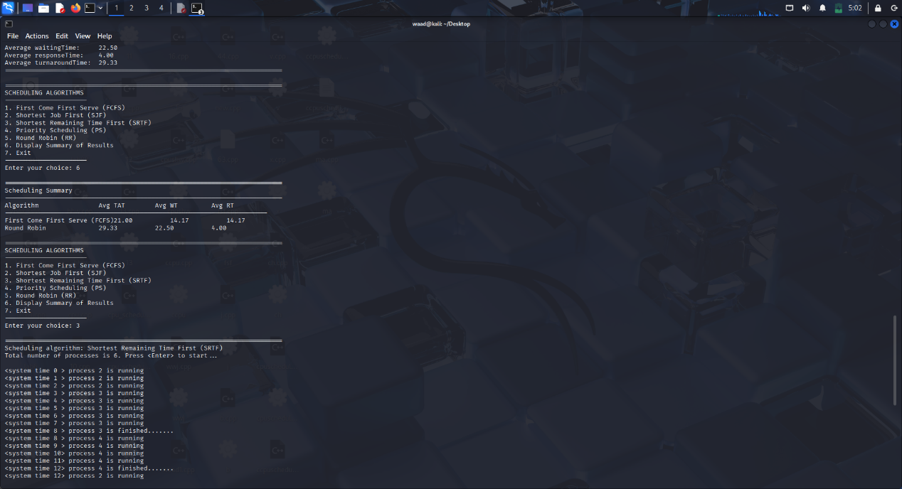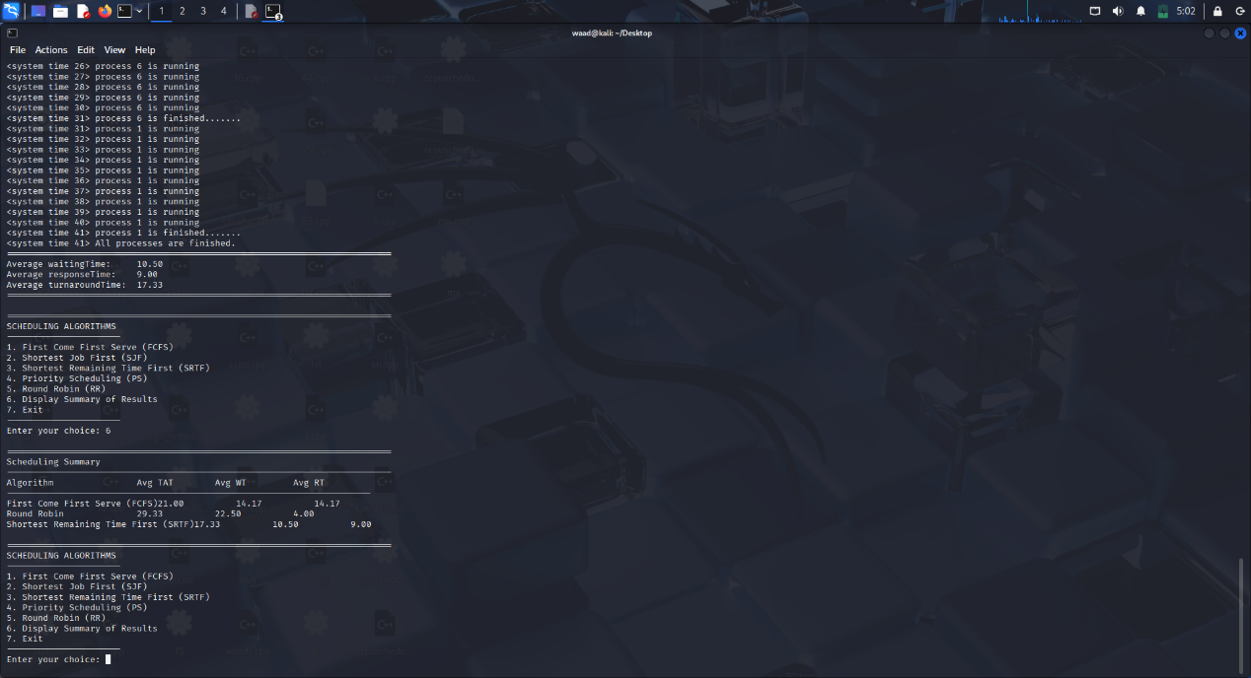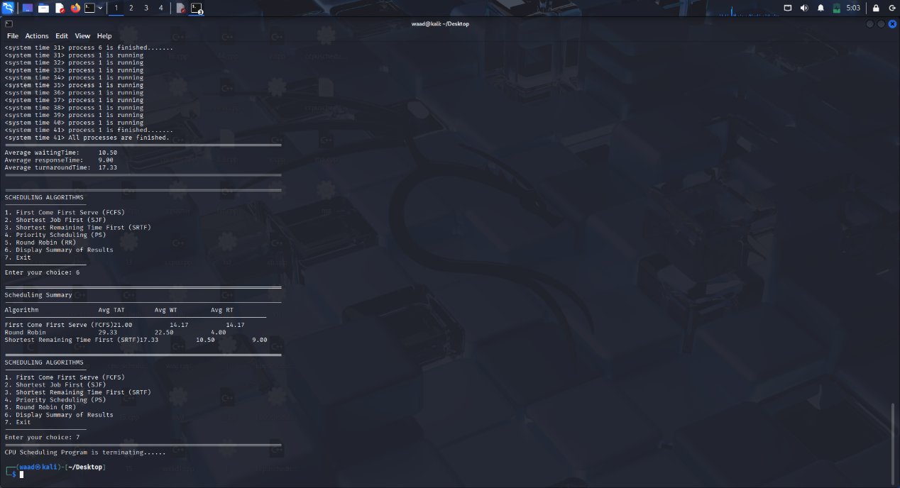

Enter Process information, line by line, in the format shown below, when finish type “end” in a new line.
pid arrivalTime burstTime
1 0 6
2 0 9
3 3 5
4 7 4
5 10 6
6 10 7
end

==========================================================================
SCHEDULING ALGORITHMS
----------------------
1. First Come First Serve (FCFS)
2. Shortest Job First (SJF)
3. Shortest Remaining Time First (SRTF)
4. Priority Scheduling (PS)
5. Round Robin (RR)
6. Display Summary of Results
7. Exit
----------------------
Enter your choice: 1

==========================================================================
Scheduling algorithm: First Come First Serve (FCFS)
Total number of processes is 6. Press <Enter> to start...

<system time 0> process 1 is running
.......
<system time 41> All processes are finished.
==========================================================================
Average waitingTime: 14.17
Average responseTime: 14.17
Average turnaroundTime: 21.00
==========================================================================
SCHEDULING ALGORITHMS
----------------------
1. First Come First Serve (FCFS)
2. Shortest Job First (SJF)
3. Shortest Remaining Time First (SRTF)
4. Priority Scheduling (PS)
5. Round Robin (RR)
6. Display Summary of Results
7. Exit
----------------------
Enter your choice: 2

==========================================================================
Scheduling algorithm: Shortest Job First (SJF)
Total number of processes is 6. Press <Enter> to start...

<system time 0> process 2 is running

<system time 41> process 1 is finished
.......
<system time 41> All processes are finished.
==========================================================================
Average waitingTime: 10.83
Average responseTime: 10.83
Average turnaroundTime: 17.67

==========================================================================
SCHEDULING ALGORITHMS
----------------------
1. First Come First Serve (FCFS)
2. Shortest Job First (SJF)
3. Shortest Remaining Time First (SRTF)
4. Priority Scheduling (PS)
5. Round Robin (RR)
6. Display Summary of Results
7. Exit
----------------------
Enter your choice: 3

==========================================================================
Scheduling algorithm: Shortest Remaining Time First (SRTF)
Total number of processes is 6. Press <Enter> to start...

<system time 0> process 2 is running
.....
<system time 1> process 2 is running
<system time 41> All processes are finished.
==========================================================================
Average waitingTime: 10.50
Average responseTime: 9.00
Average turnaroundTime: 17.3
==========================================================================
SCHEDULING ALGORITHMS
----------------------
1. First Come First Serve (FCFS)
2. Shortest Job First (SJF)
3. Shortest Remaining Time First (SRTF)
4. Priority Scheduling (PS)
5. Round Robin (RR)
6. Display Summary of Results
7. Exit
----------------------
Enter your choice: 4

==========================================================================
Scheduling algorithm: Priority Scheduling
Total number of processes is 6. Press <Enter> to start...

<system time 0> process 1 is running
<system time 1> process 1 is running
.......
<system time 41> All processes are finished.
==========================================================================
Average waitingTime: 14.17
Average responseTime: 14.17
Average turnaroundTime: 21.00
==========================================================================

==========================================================================
SCHEDULING ALGORITHMS
----------------------
1. First Come First Serve (FCFS)
2. Shortest Job First (SJF)
3. Shortest Remaining Time First (SRTF)
4. Priority Scheduling (PS)
5. Round Robin (RR)
6. Display Summary of Results
7. Exit
----------------------
Enter your choice: 5
RR is selected! What is the value of the time quantum: 2

==========================================================================
Scheduling algorithm: Round Robin
Total number of processes is 6. Press <Enter> to start...

<system time 0> process 1 is running
<system time 1> process 1 is running
<system time 41> process 6 is finished.......
<system time 41> All processes are finished.
==========================================================================
Average waitingTime: 22.50
Average responseTime: 4.00
Average turnaroundTime: 29.33
==========================================================================

==========================================================================
SCHEDULING ALGORITHMS
----------------------
1. First Come First Serve (FCFS)
2. Shortest Job First (SJF)
3. Shortest Remaining Time First (SRTF)
4. Priority Scheduling (PS)
5. Round Robin (RR)
6. Display Summary of Results
7. Exit
----------------------
Enter your choice: 6

==========================================================================
Scheduling Summary
--------------------------------------------------------------------------
Algorithm Avg TAT Avg WT Avg RT
----------------------------------------------------------------------
First Come First Serve (FCFS)21.00 14.17 14.17
Shortest Job First (SJF) 17.67 10.83 10.83
Shortest Remaining Time First (SRTF)17.33 10.50 9.00
Priority Scheduling 21.00 14.17 14.17
Round Robin 29.33 22.50 4.00

==========================================================================
SCHEDULING ALGORITHMS
----------------------
1. First Come First Serve (FCFS)
2. Shortest Job First (SJF)
3. Shortest Remaining Time First (SRTF)
4. Priority Scheduling (PS)
5. Round Robin (RR)
6. Display Summary of Results
7. Exit
----------------------
Enter your choice: 7
==========================================================================
CPU Scheduling Program is terminating......

The program is written in C++ and is designed to simulate CPU Scheduling Algorithms.
These are algorithms used by operating systems to determine which process to execute and when.

The program allows the user to manually input processes, then select the desired algorithm for scheduling, and displays the execution steps in detail on the screen.
The program includes five main algorithms:

First Come First Serve (FCFS): Processes are executed in the order they arrive, and each process starts only after the previous one finishes.

Shortest Job First (SJF): Selects the process with the shortest burst time among the ready processes.

Shortest Remaining Time First (SRTF): If a new process arrives with a shorter execution time than the current process, the current process is temporarily preempted and the new process is executed.

Priority Scheduling: The CPU selects the process with the highest priority (i.e., the smallest priority number).

Round Robin (RR): Uses a fixed time quantum for each process; if the process is not finished when the quantum expires, it is returned to the queue.

In the program’s output, the user is asked to manually enter processes by specifying the pid, arrival time, burst time, and priority, then type end when finished.
After that, a list of the algorithm names appears, and the user selects the number of the algorithm they want to execute.

The program then displays a timeline showing detailed process execution, indicating which process is running at each time moment, for example
<system time 0> process 1 is running
At the end of each algorithm, the program calculates and prints the average waiting time, response time, and turnaround time for all processes.
The user can also view a summary of results for all algorithms after executing them

